**Supplemental material**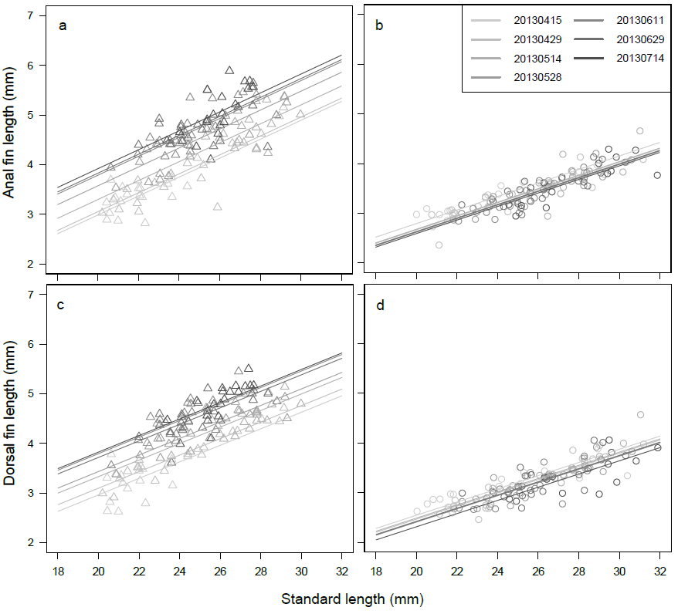

**Fig. S1** Seasonal change in the allometry between standard length and anal fin length in males (a) and females (b), and in the allometry between standard length and dorsal fin length in males (c) and females (d). The panels in (b) represented the combination between collection date and line colors

**Testing seasonal change in allometry between standard length and fin length**

In medaka, sexual dimorphism of the male fin is known to show positive allometry with respect to SL (Kawajiri et al. 2014). If the degree of sexual dimorphism in fin length increased during the reproductive season, irrespective of body size, this would provide evidence that males change their reproductive investment seasonally. To quantify the allometric relationship between the SL and fin length, we used the collection in 2013. To test seasonal change in the allometry between fin length and SL, we used linear models. The model included SL, collection date and the interaction between SL and collection date, treated as explanatory variables. The significance of each variable was tested using the *F*-test in the analysis of variance (ANOVA). The analysis was performed separately for the male and female datasets.

The fin length in males increased during the reproductive season (Fig. S1a, c). Male AFL and DFL showed similar seasonal changes; the average fin length of fish collected in July was approximately 1 mm longer than in April in all size ranges. AFL increased as the reproductive season progressed (SL: *F6, 124* = 386.03, *P* < 0.001; Collection date: *F6, 124* = 25.04, *P* < 0.001; SL × Collection date: *F6, 124* = 1.91, *P* = 0.084, Fig. S1a). DFL showed the same trend as AFL (SL: *F6, 124* = 495.45, *P* < 0.001; Collection date: *F6, 124* = 31.64, *P* < 0.001; SL × Collection date: *F6, 124* = 0.99, *P* = 0.432, Fig. S1c). In contrast to male fin length, female AFL and DFL tended to become shorter as the reproductive season progressed (Fig. S1b, d), but the effect of collection date and the interaction between the SL and collection date were not significant for AFL (SL: *F6, 114* = 422.76, *P* <0.001, Collection date: *F6, 114* = 1.897, *P* = 0.087, SL × Collection date: *F6, 114* = 0.70, *P* = 0.645), or for DFL (SL: *F6, 114* = 324.78, *P* <0.001; Collection date: *F6, 114* = 1.861, *P* = 0.094; SL × Collection date: *F6, 114* = 2.031, *P* = 0.067).

**Reference**

Kawajiri, M, Yoshida, K, Fujimoto, S, Mokodongan, DF, Ravinet, M, Kirkpatrick, M, Yamahira, K, Kitano, J (2014) Ontogenetic stage-specific quantitative trait loci contribute to divergence in developmental trajectories of sexually dimorphic fins between medaka populations. *Mol Ecol*, 23(21), 5258–5275. https://doi.org/10.1111/mec.12933

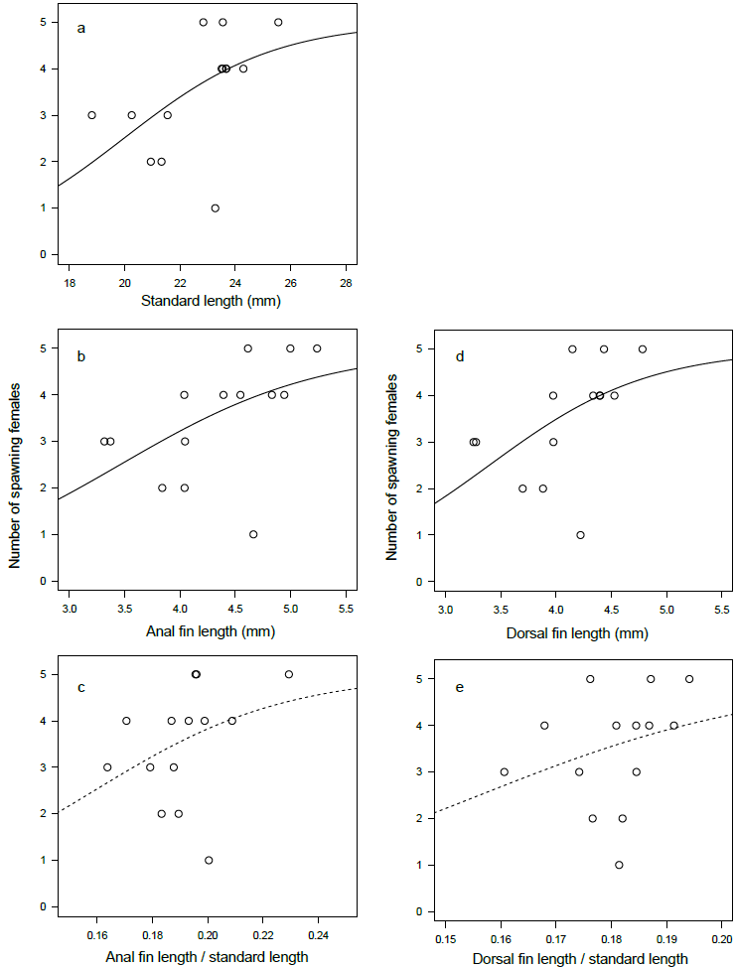

**Fig. S2** Relationships between mating success and the morphological traits standard length (SL, a), anal fin length (AFL, b), AFL/SL (c), dorsal fin length (d) and DFL/SL (e). The lines were estimated using the generalized linear model assumed with the binomial distribution. The solid and broken line represented the statistical significance by the Wald test in Table 1

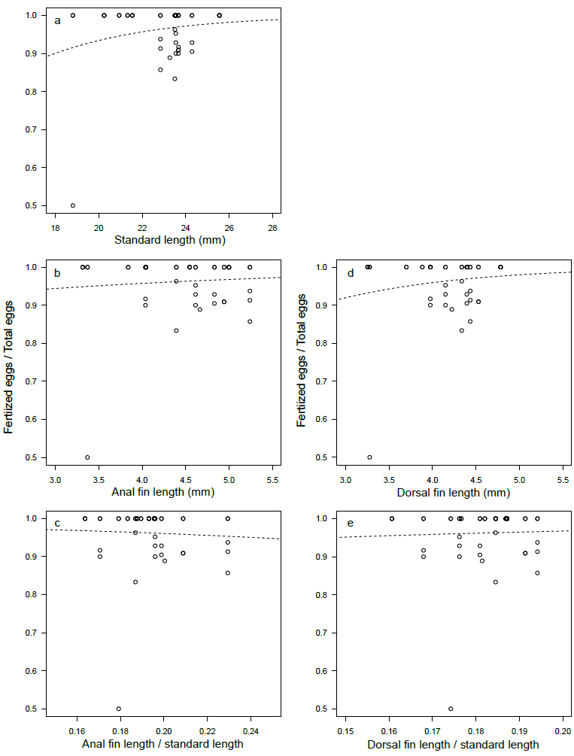

**Fig. S3** Relationships between fertilization rate and the morphological traits standard length (SL, a), anal fin length (AFL, b), AFL/SL (c), dorsal fin length (DFL, d), and DFL/SL (e). The lines represent the estimated slopes using the generalized linear model assumed with the binomial distribution. The solid and broken line represented the statistical significance by the Wald test in Table 2

**Table S1** The correlation matrix between morphological characters, using the males in the mating experiment. Lower triangle matrix represented the Pearson’s correlation coefficient and upper triangle matrix represented the *P* value in the correlation test

|  |  |  |  |  |  |
| --- | --- | --- | --- | --- | --- |
|  | **SL** | **AFL** | **DFL** | **AFL / SL** | **DFL / SL** |
| Standard length (SL) |  | < 0.001 | < 0.001 | 0.108 | 0.092 |
| Anal fin length (AFL) | 0.835 |  | < 0.001 | < 0.001 | 0.001 |
| Dorsal fin length (DFL) | 0.919 | 0.945 |  | 0.701 | 0.001 |
| AFL / SL | 0.448 | 0.865 | 0.005 |  | < 0.001 |
| DFL /SL | 0.468 | 0.787 | 0.777 | 0.861 |  |

**Table S2** Estimation of partial regression coefficients and partial correlation coefficients among male traits using structural equation modeling

|  |  |  |  |  |  |  |
| --- | --- | --- | --- | --- | --- | --- |
|  | **Parameters** |  | **Estimate** | **SE** | ***Z*** | ***P*** |
| Reproductive season | Regressions | AFL ~ SL | -0.07 | 0.13 | -0.54 | 0.593 |
| (March to July) |  | AFL ~ TW | 0.57 | 0.09 | 6.17 | 0.000 |
|  |  | AFL ~ BW | 0.40 | 0.14 | 2.85 | 0.004 |
|  |  | TW ~ BW | 0.69 | 0.09 | 7.44 | 0.000 |
|  |  |  |  |  |  |  |
|  | Correlations | SL ~~ BW | 0.83 | 0.17 | 5.03 | 0.000 |
|  |  |  |  |  |  |  |
|  | Variances | AFL | 0.271 | 0.049 | 5.523 | 0.000 |
|  |  | TW | 0.52 | 0.09 | 5.52 | 0.000 |
|  |  | SL | 0.98 | 0.18 | 5.52 | 0.000 |
|  |  | BW | 0.98 | 0.18 | 5.52 | 0.000 |
|  |  |  |  |  |  |  |
| Non-reproductive season | Regressions | AFL ~ SL | 0.85 | 0.28 | 3.04 | 0.002 |
| (August to November) |  | AFL ~ TW | 0.04 | 0.08 | 0.51 | 0.610 |
|  |  | AFL ~ BW | 0.02 | 0.28 | 0.08 | 0.936 |
|  |  | TW ~ BW | 0.50 | 0.12 | 4.05 | 0.000 |
|  |  |  |  |  |  |  |
|  | Correlations | SL ~~ BW | 0.95 | 0.19 | 4.93 | 0.000 |
|  |  |  |  |  |  |  |
|  | Variances | AFL | 0.208 | 0.042 | 5.00 | 0.000 |
|  |  | TW | 0.74 | 0.15 | 5.00 | 0.000 |
|  |  | SL | 0.98 | 0.20 | 5.00 | 0.000 |
|  |  | BW | 0.98 | 0.20 | 5.00 | 0.000 |